Mobile sales report

# Introduction:

## Objective of the analysis:

1. Dates on which the sales transactions occurred.
2. Various types of mobile devices sold, including smartphones and feature phones.
3. Different geographical regions where sales were recorded.
4. Number of units sold for each device.
5. Revenue generated from sales.
6. Information on the customers who made purchases, including age and gender.
7. Retail outlets where the sales were made.

## Data sources and methodology:

* Mobile sales table

# Findings:

1. January has the most sell revenue
2. Huge has the most revenue in mobile model
3. Johnson LLC has the most sell revenue
4. Lake Amanda is the most geographical region where sales were recorded
5. Females are the most customers who made purchases
6. 55 is the age where most customers made purchases
7. Fine is the most sold mobile model

# Conclusion:

* We should focus on Johnson LLC brand as it’s the most selling
* We should focus on increasing the sales in the other branches by taking lake Amanda as an example
* We should target the young people with more ads

# Example dashboard snapshots:

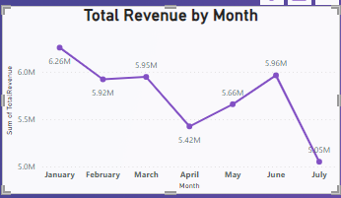total revenue by month:

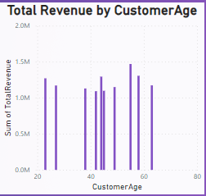total revenue by customer age: